# Test Document for To allow Previous Months Entries in Warehouse Receipts

Testing in Warehouse Receipt for R10143222

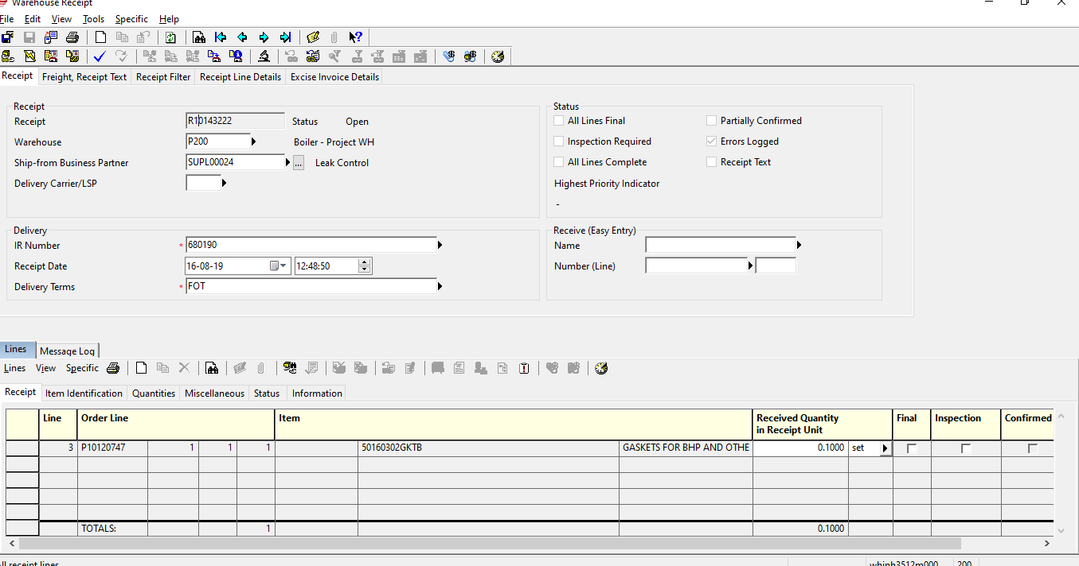

After confirm its confirmed in previous date.

